**Project Overview**

As an aspiring data analyst and former job seeker, I created this project to provide valuable insights into data-related careers. By analyzing a dataset sourced from GitHub, I explored key aspects such as the types of available data jobs, required technical skills, optimal times to apply, the correlation between skills and salary, and popular job posting platforms.

Using my skills in Excel (Power Query, Data Analysis Tool), ETL, Power BI (DAX, Data Visualization), and Structured Query Language (SQL), I uncovered the following insights:

The dataset used for this analysis is sourced from GitHub Luke Barousse.

**The goal of this project is to provide an in-depth analysis of:**

* Various types of data analyst careers.
* Required technical skills.
* Salary ranges and influencing factors.
* Popular job posting platforms.
* Patterns in job postings based on dates and time.

**Problem Statement**

1. What types of data-related jobs are available in the market, and which were most in demand in 2023?
2. What are the popular technical skills required for data-related jobs?
3. Does having multiple technical skills lead to higher salaries and better qualifications for roles?
4. What are the best months, weekdays, and times for applicants to apply for work?
5. What are the top 5 websites to apply for data-related jobs?

**Data Overview**

* Dataset Source: [GitHub: Luke Barousse](https://github.com/lukebarousse/Excel_Data_Analytics_Course/tree/main/0_Resources/Datasets)
* File Size: 3,754 KB
* Data Structure:
  + job_title_short, job_title, job_location, job_via, job_schedule_type, job_work_from_home, search_location, job_posted_date, job_no_degree_mention, job_health_insurance, job_country, salary_rate, salary_year_avg, salary_hour_avg, company_name, job_skills.

**Exploratory Data Analysis (EDA) Questions**

**Table Analysis**

1. Total number of rows and columns in the dataset.
2. The range and scope of the data.

**Data-Related Jobs Analysis**

1. Types of data-related jobs available and the most popular roles.
2. Percentage of work-from-home vs. onsite jobs.
3. Percentage of jobs offering health insurance.

**Salary Analysis**

1. Average yearly/hourly salaries for data-related jobs.
2. Correlation between job positions and salary levels.
3. Impact of multiple technical skills on yearly salaries.
4. Comparison of average yearly salaries for work-from-home and onsite jobs.
5. Average yearly salary for jobs offering insurance vs. those without.

**Job Platform Analysis**

1. Top 5 most popular job platforms for data-related jobs.

**Date and Time Analysis**

1. Distribution of job postings by month, weekday, and time.

**Country Analysis**

1. Countries with the highest number of job postings.

**Tools and Their Applications**

* Excel: Used for data cleaning and basic analysis
* SQL Server Management: Utilized for performing Exploratory Data Analysis (EDA) and querying data to gain deeper insights.
* Power BI: Applied for Extract, Transform, and Load (ETL) processes, data visualization, data cleaning, and creating Data Analysis Expressions (DAX)

**Extract Transform and Load Data Using Excel**

**Extract**

The data was extracted by downloading it from GitHub and importing it into an Excel workbook.

**Transform**

* The data was transformed using Excel's Power Query for cleaning. This include
  + Removing Duplicates
  + Standardize Data
  + Removing Blank and Null data
  + Removing Unnecessary Data

Tables Used:

Job_data table

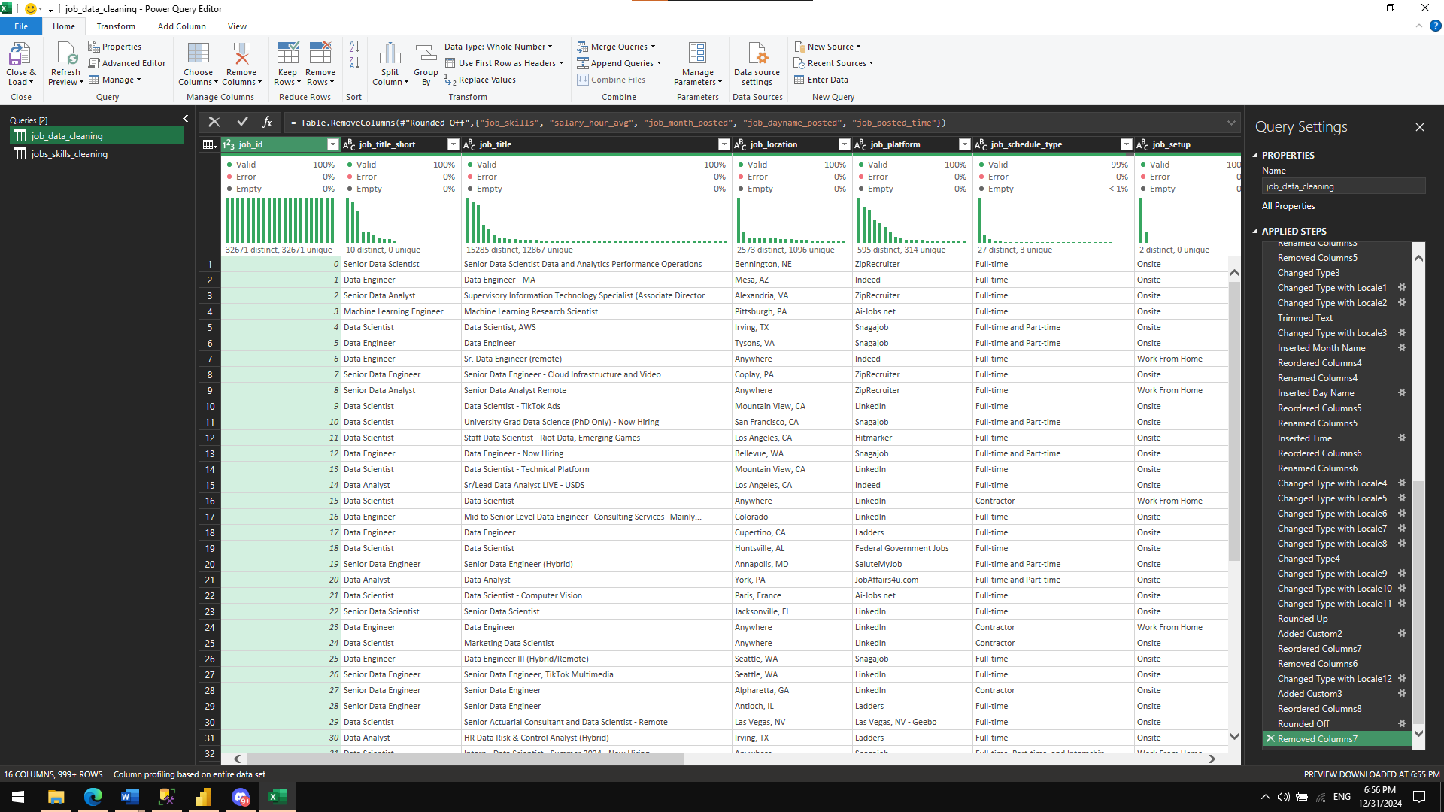

Jobs_skills table

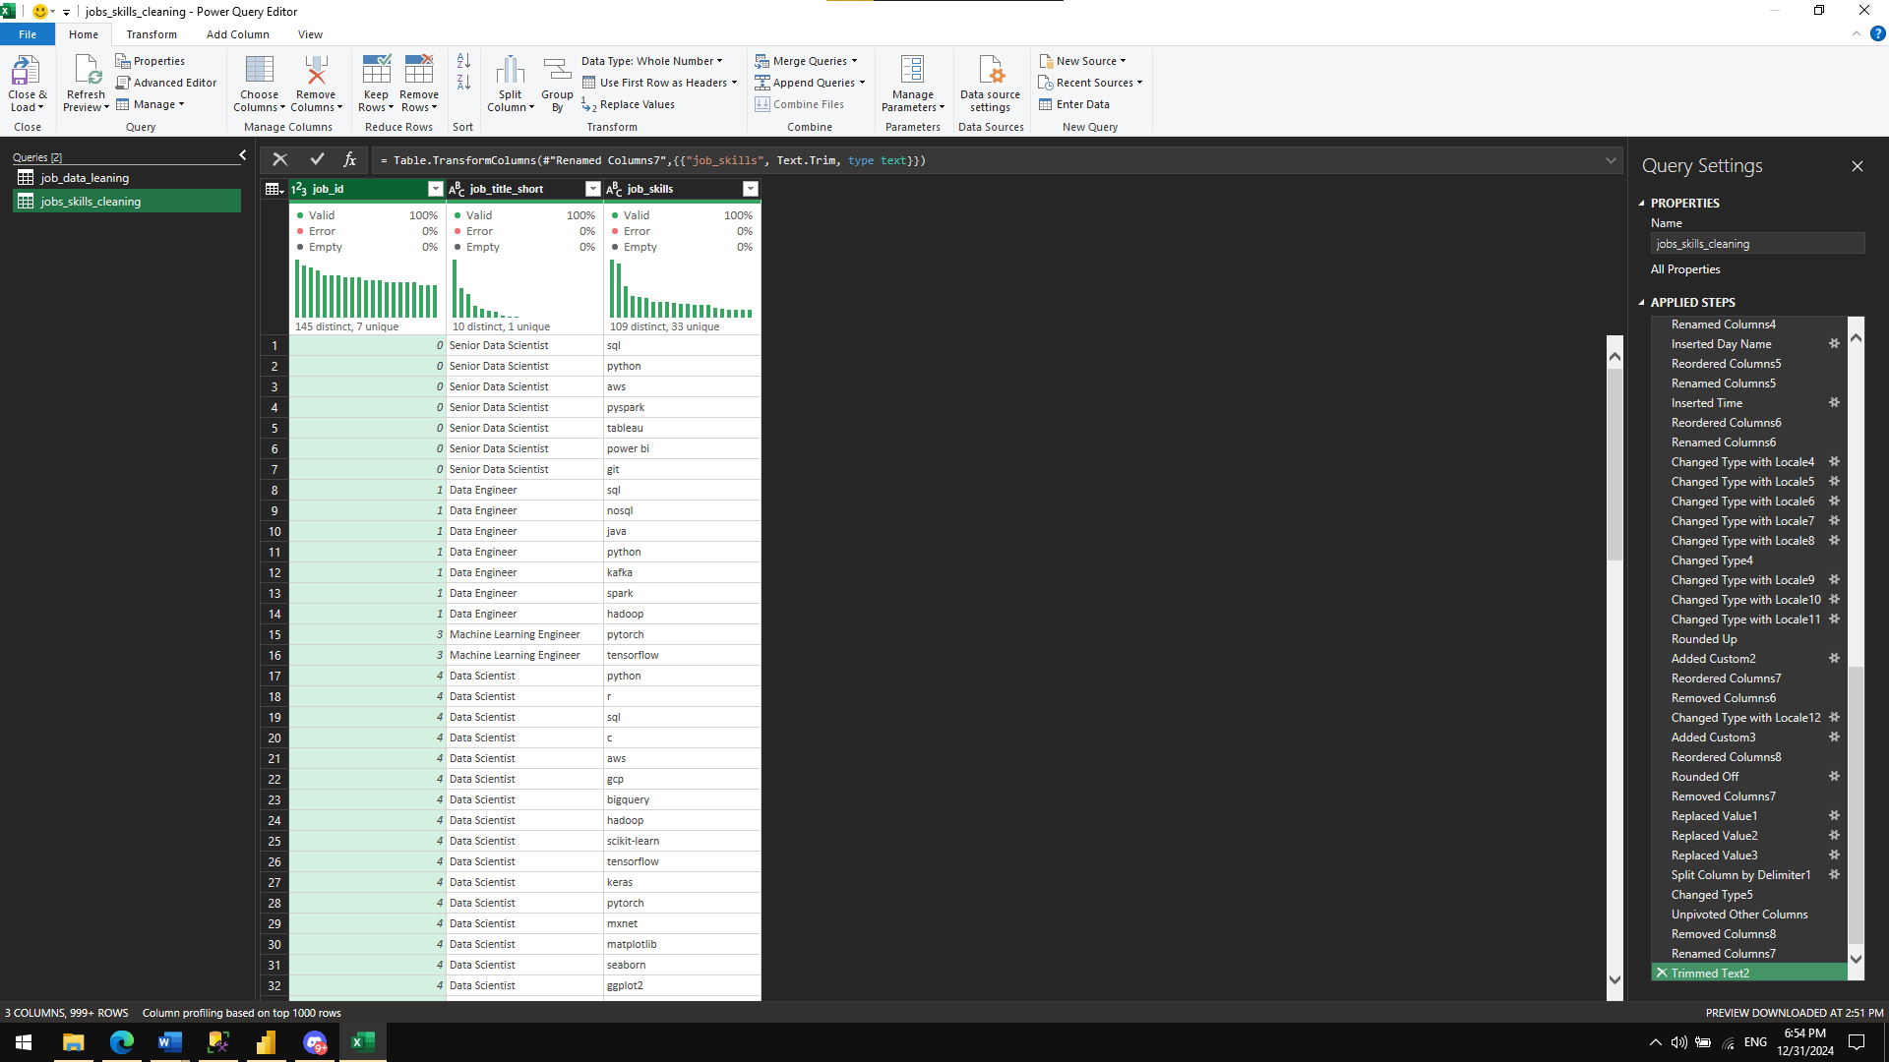

**Load**

After the transforming the data, the cleaned data was loaded into a new Excel workbook for further use.

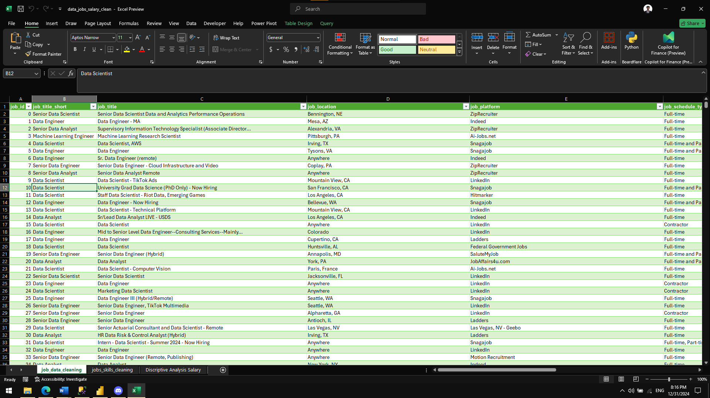

**Descriptive Analysis Using Excel**

I utilized Excel's Descriptive Analysis tool to obtain key statistical metrics for salary data. This included insights into measures such as the mean, median, standard deviation, and range for both yearly and hourly salaries.

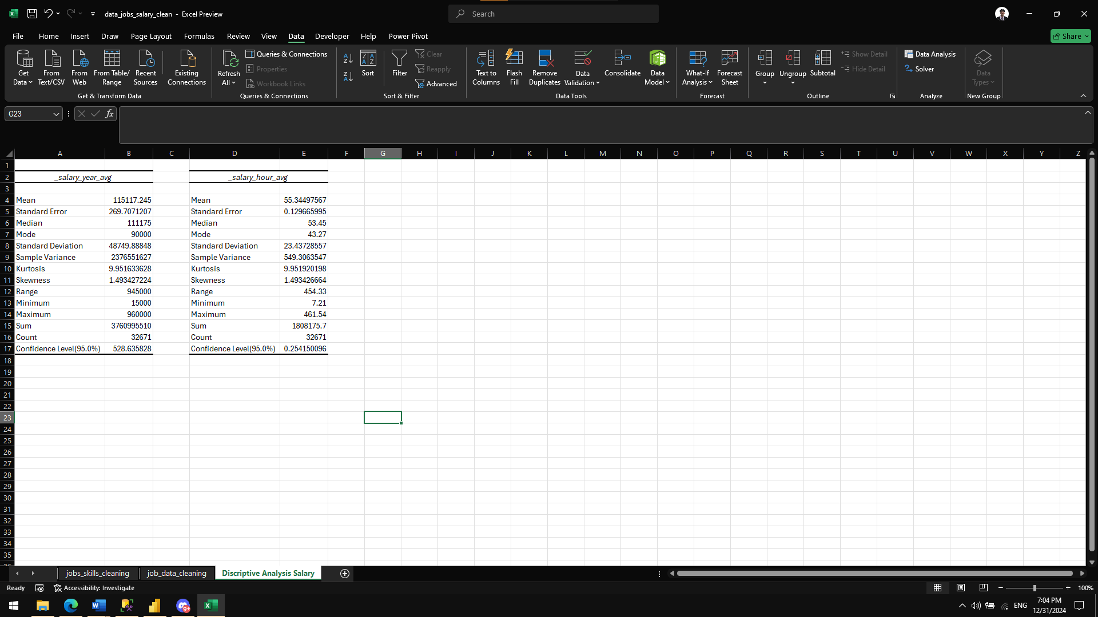

Explanatory Data Analysis Using SQL Server Management

* I first created a database and then used the SQL Server Import and Export Wizard to import the datasets from the Excel file.

-- Creating Database

DROP DATABASE IF EXISTS data_jobs_eda_project;

CREATE DATABASE data_jobs_eda_project;

* To optimize performance, I created an index for faster and more efficient querying, as the dataset contained a large volume of data and takes a minutes to load.

-- Creating an index for table data_jobs and jobs_skills for faster joins and querying

CREATE INDEX idx_job_table ON data_jobs (job_id, job_title_short, _salary_year_avg, _salary_hour_avg, job_setup)

CREATE INDEX idx_job_id_jobs_skills ON jobs_skills (job_id);

* Table analysis, this code displays the information about the table.

--Table Analysis

--1. Total number of rows and columns in the dataset.

--2. The range and scope of the data.

SELECT COUNT(*) rows_count -- counting the number of rows in the table.

FROM data_jobs; -- 32671 number of rows

SELECT MIN(FORMAT(job_posted_date,'yyyy-mm-dd')) min_date, -- Year 2023 Janruary 1 to December 31

MAX(FORMAT(job_posted_date, 'yyyy-mm-dd')) max_date,

MIN(_salary_year_avg) min_salary, -- Salary range

MAX(_salary_year_avg) max_salary

FROM data_jobs;

-- DIstinct Data Jobs Role

SELECT DISTINCT job_title_short -- 10 Distinct data jobs related

FROM data_jobs;

EXEC SP_HELP data_jobs; -- display information about the table.

-- 19 columns

SELECT COUNT(*) rows_count

FROM jobs_skills; -- 167266 number of rows

EXEC SP_HELP jobs_skills; -- 3 columns

* Display data-related jobs and number of job posted in the dataset

--Data-Related Jobs Analysis

--1. Types of data-related jobs available and the most popular roles.

SELECT job_title_short,

COUNT(job_title_short) number_of_job_posted -- Most popular posted data jobs is data analyst

FROM data_jobs

GROUP BY job_title_short

ORDER BY number_of_job_posted DESC;

* This displays the percentage of work from home and onsite jobs in the dataset as well the average year and hour salary for work from home and onsite jobs.

--2. Percentage of work-from-home vs. onsite jobs and salary comparison.

SELECT job_setup,

ROUND(AVG(CASE WHEN salary_rate = 'year' THEN _salary_year_avg END), 0) AS year_avg_salary,

ROUND(AVG(CASE WHEN salary_rate = 'hour' THEN _salary_hour_avg END), 0) AS hour_avg_salary,

CONCAT(ROUND(CAST(COUNT(job_id) AS FLOAT) / (SELECT COUNT(*) FROM data_jobs) * 100, 0), '%') AS percentage_of_job_setup

FROM data_jobs

GROUP BY job_setup;

* This displays the percentage of jobs that offer Insurance and not Insured company in the dataset as well the average year and hour salary for work from home and onsite jobs.

--3. Percentage of jobs offering health insurance and salary comparison.

SELECT CASE WHEN job_health_insurance = 0 THEN 'No Insurance'

ELSE 'With Insurance' END job_health_insurance,

ROUND(AVG(CASE WHEN salary_rate = 'year' THEN _salary_year_avg END), 0) AS year_avg_salary,

ROUND(AVG(CASE WHEN salary_rate = 'hour' THEN _salary_hour_avg END), 0) AS hour_avg_salary,

CONCAT(ROUND(CAST(COUNT(job_health_insurance) AS FLOAT) / (SELECT COUNT(*) FROM data_jobs) * 100, 0), '%') AS percentage

FROM data_jobs

GROUP BY job_health_insurance;

* This Display the Average year/hour salaries for data related jobs

--Salary Analysis

--1. Average yearly/hourly salaries for data-related jobs.

SELECT job_title_short,

ROUND(AVG(CASE WHEN salary_rate = 'year' THEN _salary_year_avg END), 0) AS avg_salary_year,

ROUND(AVG(CASE WHEN salary_rate = 'hour' THEN _salary_hour_avg END), 0) AS avg_salary_hour

FROM data_jobs

GROUP BY job_title_short

ORDER BY avg_salary_year DESC;

* To summarize average salary levels (yearly and hourly) and the number of job postings for each job title. While it doesn't compute a direct correlation, the results can be visualized in Power BI for better interpretation of trends.

--2. The correlation between job positions and salary levels is not directly displayed.

-- but is represented visually using a Power BI graph for better interpretation and insights.

SELECT job_title_short,

ROUND(AVG(CASE WHEN salary_rate = 'year' THEN _salary_year_avg END), 0) AS avg_salary_year,

ROUND(AVG(CASE WHEN salary_rate = 'hour' THEN _salary_hour_avg END), 0) AS avg_salary_hour,

COUNT(*) jobs_posted

FROM data_jobs

GROUP BY job_title_short

ORDER BY avg_salary_year DESC, avg_salary_hour DESC;

• Combines information about the average number of skills required for each job position and the average salary levels (both yearly and hourly). Provides a holistic view of how skill requirements relate to salary levels for each job title.

--3. Impact of multiple technical skills on yearly salaries.

WITH cte AS (

SELECT job_title_short,

AVG(Skills_count) AS avg_skill_count

FROM (SELECT job_id,

job_title_short,

COUNT(job_skills) AS Skills_count

FROM jobs_skills

GROUP BY job_id, job_title_short) AS skills_table

GROUP BY job_title_short

),

cte2 AS

(

SELECT job_title_short,

AVG(CASE WHEN salary_rate = 'year' THEN _salary_year_avg END) AS year_avg_salary,

AVG(CASE WHEN salary_rate = 'hour' THEN _salary_hour_avg END) AS hour_avg_salary

FROM data_jobs

GROUP BY job_title_short

)

SELECT c1.job_title_short,

c1.avg_skill_count,

ROUND(c2.year_avg_salary, 0) AS avg_year_salary,

ROUND(c2.hour_avg_salary, 0) AS hour_avg_salary

FROM cte AS c1

INNER JOIN cte2 AS c2

ON c1.job_title_short = c2.job_title_short;

* Display Top 10 most popular job platforms for data-related jobs.

--Job Platform Analysis

--1. Top 10 most popular job platforms for data-related jobs.

SELECT job_platform,

COUNT(job_id) number_of_jobspost

FROM data_jobs

GROUP BY job_platform

ORDER BY number_of_jobspost DESC;

* **Month Distribution**: Helps identify seasonal trends in job postings.
* **Weekday Distribution**: Provides insights into the most active days of the week for job postings.
* **Time Distribution**: Shows the most common timeframes for job postings, allowing job seekers to be more proactive during these hours.

--Date and Time Analysis

--1. Distribution of job postings by month, weekday, and time.

-- Couting job posted based on month

SELECT DATENAME(MONTH, job_posted_date) Month,

COUNT(job_id) number_of_posted_jobs

FROM data_jobs

GROUP BY DATENAME(MONTH, job_posted_date)

ORDER BY number_of_posted_jobs DESC;

-- Couting job posted based on weekday

SELECT DATENAME(WEEKDAY, job_posted_date) weekdays,

COUNT(job_id) number_of_posted_jobs

FROM data_jobs

GROUP BY DATENAME(WEEKDAY, job_posted_date)

ORDER BY number_of_posted_jobs DESC;

-- Couting job posted based on time

WITH cte AS (

SELECT

CASE

WHEN CAST(job_posted_date AS TIME) BETWEEN '00:00:00' AND '06:59:59' THEN '12 to 06 AM'

WHEN CAST(job_posted_date AS TIME) BETWEEN '07:00:00' AND '11:59:59' THEN '07 to 11 AM'

WHEN CAST(job_posted_date AS TIME) BETWEEN '12:00:00' AND '18:59:59' THEN '12 to 06 PM'

WHEN CAST(job_posted_date AS TIME) BETWEEN '19:00:00' AND '23:59:59' THEN '07 to 12 PM'

END AS Time_Category,

job_id

FROM data_jobs

)

SELECT Time_Category,

COUNT(job_id) count_job_postings

FROM cte

GROUP BY Time_Category

ORDER BY count_job_postings DESC;

* Display Countries with the highest number of job postings

--Country Analysis

--1. Countries with the highest number of job postings.

SELECT job_country,

COUNT(job_id) job_postings

FROM data_jobs

GROUP BY job_country

ORDER BY job_postings DESC;

**Power BI Data Visualization**

1. What types of data-related jobs are available in the market, and which were most in demand in 2023?

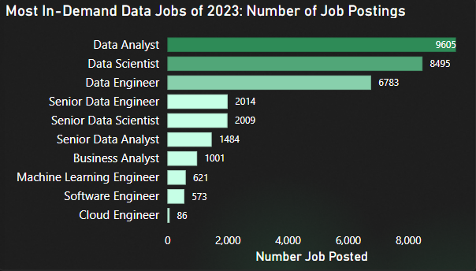

**Visualization: Stacked Bar Chart**

**Y-Axis: Job Title**

* + **By grouping the job title based on the similar job categories.**

**X-Axis: Count of Jobs posted**

* + **By doing the COUNT() formula in Dax formula I get the count of job being posted per job title**

**Insight:**Data Analyst is the most in-demand role, with the highest number of job postings, followed closely by Data Scientist. On the other hand, Cloud Engineer has the fewest job postings.

**Effect:**Since Data Analyst roles are highly sought after, competition in this area is significant. Emerging roles such as Cloud Engineer, Software Engineer, and Machine Learning Engineer have fewer postings, indicating they are newer and less saturated markets.

**Solution:**  
Consider the industry you want to focus on, as all data-related roles are competitive. Choose a role based on your skills, interests, and market trends.

1. What are the popular technical skills required for data-related jobs?

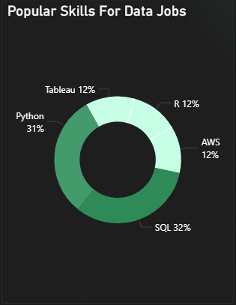

**Visualization: Donut Chart**

**Legend:**

* + **Top 5 most posted skills in the job requirement skills basing by the count of the skills posted**

**Values:**

* + **By getting the COUNT() of the job skills and converting it into the % of grand total**

**Insight:**SQL ranks as the most frequently required skill, followed by Python, indicating their importance in data-related roles. Tableau has the fewest job postings among the listed skills.

**Effect:**Most companies prioritize SQL and Python skills in data-related job requirements.

**Solution:**Focus on acquiring and mastering the in-demand skills like SQL and Python before applying for positions to increase your chances of being selected.

1. Does having multiple technical skills lead to higher salaries and better qualifications for roles?

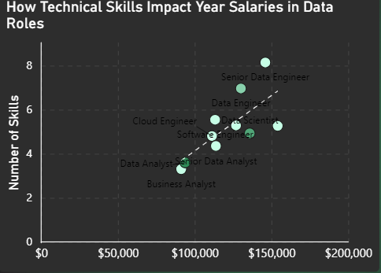

**Visualization:** Scatter Plot Chart with Trend Line

Values: Job Title

* + Getting the distinct values from the job_title_short column

X-Axis: Average Salary for the Data Related Jobs

* + By using the CALCULATE(AVERAGE) DAX in the column salary rate and _salary_year_avg column I able get the average salary of data jobs salary rate year

Y-Axis: Average Required Number of kills

* + **By creating the another table and separating the skills requirement and using the count() DAX functions to count the skills required for every jobs posted and using the count to calculate the average required number of skills for every job posted. I able to get the average skills for the data related jobs.**

**Trend Line: Dash Line**

* + **The trend line display the positive correlation between number of skills and salary year rate for data jobs**

**Insight:**There is a positive correlation between the number of technical skills required and the average annual salary for data-related roles. Senior roles such as Senior Data Engineer demand more skills and offer higher salaries.

**Effect:**  
Higher-level positions require a broader skill set and offer higher compensation. Aspiring for such roles requires a solid foundation in technical skills and continuous learning.

**Solution:**

Evaluate your current skills and knowledge before targeting higher-level roles. Invest in learning and upskilling to meet the qualifications and skill requirements for senior positions.

1. What are the best months, weekdays, and times for applicants to apply for work?

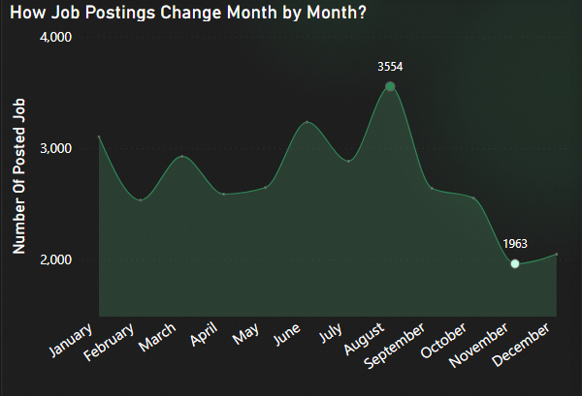

Visualizations: Line Chart, Stacked Bar Chart, Clustered Bar Chart

X-Axis: Displaying the month name for whole year for 2023

* + By using the DAX function Date Hierarchy, I able to get the month name.

Y-Axis: Count of Job Posted

* + By using the DAX Functions CALCULATE(COUNT) the column I able to get the number of job being posted very month.

Y-Axis: Max and Min Value for number of job posted every month

* + By Using the DAX function MAX and MIN I able to highlight the maximum and minimum value of number of job being posted month by month.

Best weekdays for the applicants to apply?

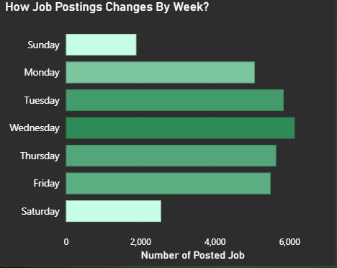

Y-Axis: Job Posted Week

* + By using DAX FORMAT I able to format and get the week name for the job_posted_date column

X-Axis: Number of Posted job

* + By using DAX function COUNT I able to get the count of job posted for every week name.

Best time for the applicants to apply?

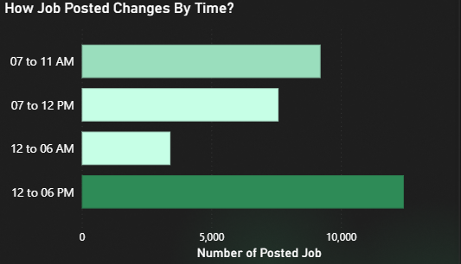

Y-Axis: Time Category

* + By using the DAX format I able to get a time format of job_posted_date column

And using that I create another DAX caculation where I use SWITCH to create a grouping for Time category

X-Axis: Count of Job posted

* + By suing the DAX COUNT function I able to get the number of job being posted by time category that I created.

Overall Insight:

* + **Month**: August shows the highest number of job postings, with significant competition but also higher employer engagement.
  + **Day of the Week**: Wednesday has the most job postings, making it an ideal day to apply.
  + **Time of Day**: Most jobs are posted between **12 PM to 6 PM**, indicating optimal activity during this period.

**Effect:**

* + Applying in **August** (the peak month) may result in **higher competition** due to a large number of job seekers targeting the same opportunities. However, it also increases the likelihood of **better employer responses** since companies are actively hiring during this time.
  + Applying on **Wednesdays** and during the **12 PM to 6 PM timeframe** ensures your application is visible when most jobs are posted and employers are more likely to be reviewing submissions.

**Solution:**

* To maximize your chances, target your job applications on **Wednesdays in August** and during the **afternoon (12 PM to 6 PM)**.
* This strategy ensures your application is submitted when job postings are most active, increasing the probability of standing out to recruiters.

1. What are the top 5 websites to apply for data-related jobs?

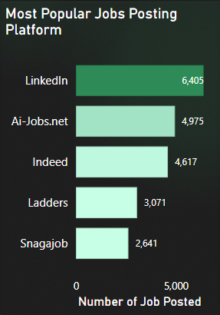

**Visualization:** Clustered Bar Chart

Y-Axis: Job_Platform

* + By transforming the column Job_Platform I able to get the clean distinct job platform.

X-Axis: Count of Job Posted

* + By using the DAX COUNT function I able to get the number of job being posted for every platform.

**Insight:**

* **LinkedIn** is the leading platform for data-related job postings, offering the highest number of opportunities, Platforms like **AI-Jobs.net** and **Indeed** also provide substantial job listings, catering to both specialized and general audiences.

**Effect:**

* Focusing on **LinkedIn** increases your access to a broader range of jobs, but also exposes you to **higher competition** from other applicants. Using platforms with fewer listings, such as **Ladders** and **Snagajob**, may lead to less competition, potentially improving your chances for roles with fewer applicants.

**Solution:**

* **Primary Focus**: Prioritize applying on **LinkedIn**, leveraging its extensive network and job listings for data-related roles, or Explore **Ladders** and **Snagajob** to identify hidden opportunities with less competition and regularly update and optimize your profiles on these platforms to improve visibility and attract recruiters.

Conclusion

This project highlights the essential factors for navigating a data-related career. It combines data analysis and visualization to guide aspiring professionals in making informed decisions about their career paths. I hope it inspires others to embrace this field, master the necessary skills, and achieve their career goals.